

Baking Education Resources

Baking Education,

* Baking Food Safety videos, resources <https://www.homebaking.org/baking-food-safety/>
* Pre-K to Secondary Baking education resources <https://www.homebaking.org/distance-learning/>
* Educator Award entry information, <https://www.homebaking.org/educator-award/>
* Getting Started, <https://www.homebaking.org/getting-started/>
* Test kitchen recipes/, Smart Snack in-school bake sale formulas, <https://www.homebaking.org/recipes/>
* Whole Grain Baking 101. Ancient, Heritage, Modern and GF Baking Guide, <https://www.homebaking.org/wp-content/uploads/2019/05/WGBaking101REV.pdf>

Baking Calendar of Events and Hacks <https://www.homebaking.org/blog/>

Baking E-News for Educators, (Monthly) <https://www.homebaking.org/newsletter/>

* Sign-up to join 116,000 educators in receiving baking news and forums.

Baker’s Spotlight <https://www.homebaking.org/bakers-spotlight/>

Baking Glossary of Terms, Techniques <https://www.homebaking.org/glossary/>

Bakery Science Careers, Education videos, speaker contacts, posters – *Kansas State U. Baking and Milling Science are unique in the U.S. offering B.S., M.S. and Ph.D degrees. There are a shortage of graduates in the U.S. and world.* [https://youtu.be/wCxbj67DKUY](https://youtu.be/wCxbj67DKUY" \t "_blank)

* Baking and Milling career classroom posters. Send a request for posters to Brenda Heptig [bheptig@ksu.edu](mailto:bheptig@ksu.edu" \t "_blank) . This [link](https://www.grains.k-state.edu/recruiting/bakesci/index.html" \t "_blank) has a place to download the poster too… [https://www.grains.k-state.edu/recruiting/bakesci/index.html](https://www.grains.k-state.edu/recruiting/bakesci/index.html" \t "_blank).

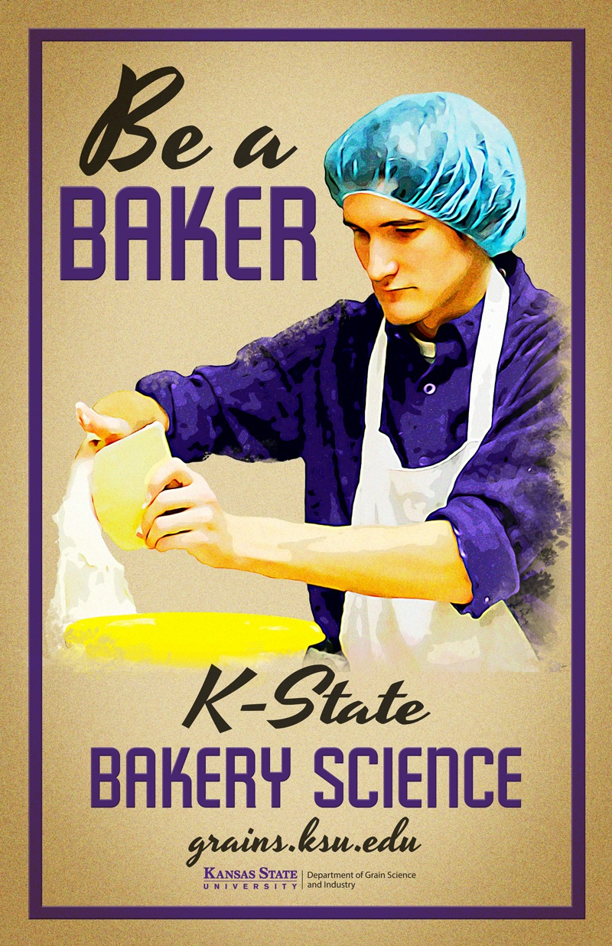

* The Bakers National Education Fund (BNEF) [https://www.futureinbaking.com/](https://www.futureinbaking.com/" \t "_blank) website “Teachers can contact/connect with KSU alumni who would be glad to talk to their classes (virtually or in person) including alumni around the country that have started going into high schools to promote baking careers (and K-State).” Aaron Clanton, KSU National Baking Education Faculty.

Baking Biscuits and It’s Cousins - Chef Devin Donley, Renwood Milling, Newton, NC

[https://youtu.be/iEC5gZv8SqA](https://youtu.be/iEC5gZv8SqA" \t "_blank)

* Check out Baking Science Experiment, Lab 5, Fats, A Baker’s Dozen
* Flour is NOT Just Flour, <https://www.homebaking.org/distance-learning/>

Cookie Science Power point- Lisa Pluff, Baking Science/FCS Ed.-- Google Link-

* Cookie Science - Ingredient Functionality
* [https://docs.google.com/presentation/d/1yYxEDwGW73mGCMGA1bNVuEr3sDjEbwTzSfBZG14Xk60/edit?usp=sharing](https://docs.google.com/presentation/d/1yYxEDwGW73mGCMGA1bNVuEr3sDjEbwTzSfBZG14Xk60/edit?usp=sharing" \t "_blank)
* Cookie Science - Teaching Strategies
* [https://docs.google.com/presentation/d/18-Co1vXGTAamwkRx9vJwMClqMgvIuMcs4zrD4bc92G4/edit?usp=sharing](https://docs.google.com/presentation/d/18-Co1vXGTAamwkRx9vJwMClqMgvIuMcs4zrD4bc92G4/edit?usp=sharing" \t "_blank)
* Access *A Baker’s Dozen Labs,* Cookie Science Baking Experiment, Lab 7

***Food Insight***- International Food Information Council consumer surveys, food science

[www.foodinsight.org](http://www.foodinsight.org)

Home Baking Association Baking, Milling, Ingredient and Equipment Members:

<https://www.homebaking.org/members/>

* Farm to Oven commodity and corporate baking connections.

North American Millers Association, What is Milling? What’s in a Kernel? Food Safety

<https://namamillers.org/consumer-resources/what-is-milling/>

Lessons Plans: <https://www.homebaking.org/lesson-plans/>

* NEW! Sugar Detectives, <https://www.homebaking.org/sugar-resources/>
* Bake for Funds 2020, www.homebaking.org
* Marla Prusa’s winning lesson *Pastry Pizzazz* coming for Fall 2021!

Recipes, <https://www.homebaking.org/recipes/> (Includes Smart Snack sell-in-school-hours formulas)

Resources/Shop- *A Baker’s Dozen Labs USB; Dough Sculpting 101 DVD; Baker Aprons;*

*Baking Guide Cards; 50 5-Minute Baking Activities,* <https://www.homebaking.org/store/>

* The Butter Book special offer, <https://www.homebaking.org/exciting-butter-book-offer-from-hba/>
* Thermoworks.com Food Temps Chart , <https://www.thermoworks.com/pdf/chef_recommended_temps.pdf>

Sensory Analysis, Spice Cake, Lab 7, SWEET! [https://drive.google.com/drive/folders/1iIpUbKgPwBschN4l0FZ1JKgNgYeKQuZS?usp=sharing](https://drive.google.com/drive/folders/1iIpUbKgPwBschN4l0FZ1JKgNgYeKQuZS?usp=sharing" \t "_blank)

* Kitchen Science- Baking for Special Needs-   
  <https://www.homebaking.org/wp-content/uploads/2019/07/final_kitchenscience-1.pdf>

*Since Sliced Bread* – baking industry innovations podcast, bakingbusiness.com

<https://www.bakingbusiness.com/articles/54115-since-sliced-bread-explores-innovation-and-product-development?e=hbadavis@gmail.com&utm_source=Baking+Business+Daily&utm_medium=Newsletter&oly_enc_id=5235H6825612B8Z>

Soft Wrap, (Tangzhong Method), <https://www.homebaking.org/recipe-items/fresh-flatbread/>

* Baker’s Spotlight, <https://www.homebaking.org/may-bakers-spotlight/>

Sugar STEAM and Resource Teaching Kit, Grades 7-12

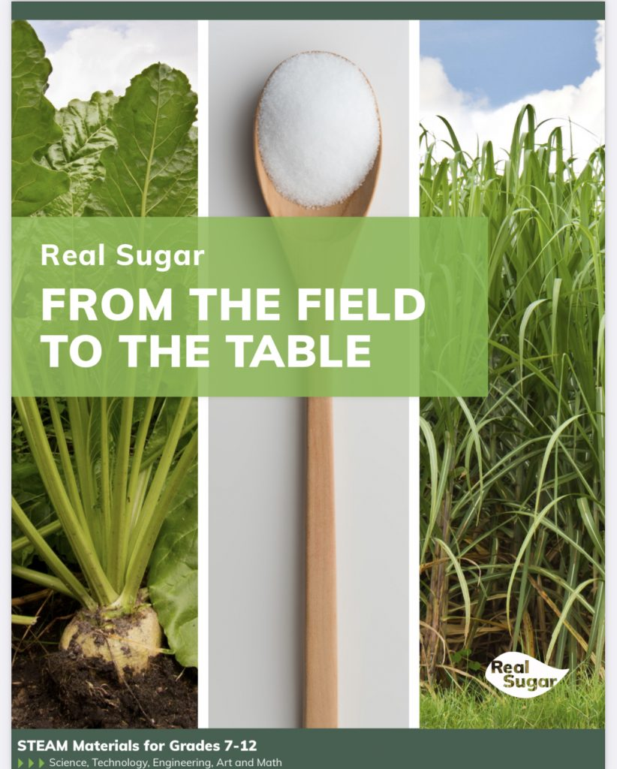

<https://www.sugar.org/wp-content/uploads/Field-To-Table-STEM-Packet_digital2.pdf>

* Baking Guide to Sugar in Baking, Test Kitchen Tips, Techniques

<https://www.homebaking.org/lesson-plans/>

Much More at [www.sugar.org](http://www.sugar.org)

* C&H and Domino Test Kitchens- [www.chsugar.com](http://www.chsugar.com) and [www.dominosugar.com](http://www.dominosugar.com)

Thermoworks, Chef Earl Martin and FCS/CTE offers,

* *Quality Baking Temperatures*https://www.thermoworks.com/home-baking-association

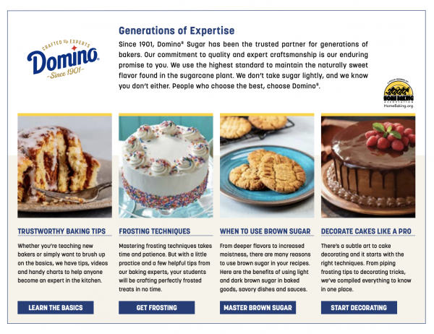

Wheat Foods Council, [WheatFoods.org](http://www.WheatFoods.org)

* Videos; Ask Brett about Wheat; Wheat Facts; Infographics; power points
* Nutrition, Health and Fitness
* *E-Kernels* online Magazine and *CEU Credits*